**Project Development Phase**

**Delivery of Sprint-1**

|  |  |
| --- | --- |
| **Date** | **07 November 2022** |
| **Team ID** | **PNT2022TMID11633** |
| **Project Name** | **Analytics for Hospitals' Health-Care Data** |
| **Team Members** | **Dharani Kumar C**  **Keerthivasan B**  **Akil V**  **Mohammed upayathulla M** |
| **Project Development Phase:** | |  |  | | --- | --- | | **Sprint-1:**   * Data Collection * Data Preparation   **Sprint-2:**   * Data Exploration | **Sprint-3:**   * Dashboard Creation   **Sprint-4:**   * Report Creation * Story Creation | |

**Sprint-1:**

## **Data Collection**: Download the Dataset link : https://drive.google.com/file/d/1slC0MhsJHeuODVkhIXrdNOX_aBDySSBh/view?usp=share_link **Load the Dataset: Tool used:** IBM Cognos Analytics

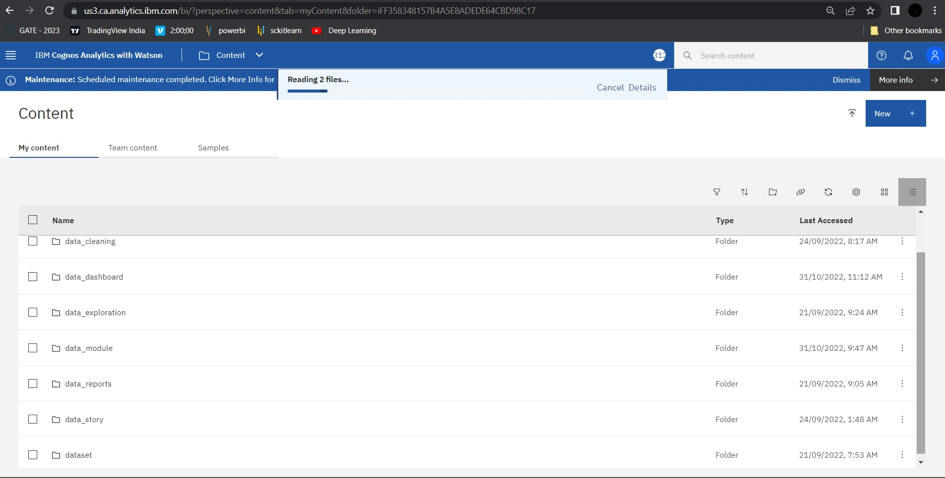

**Data Preparation:**

Prepare the Dataset

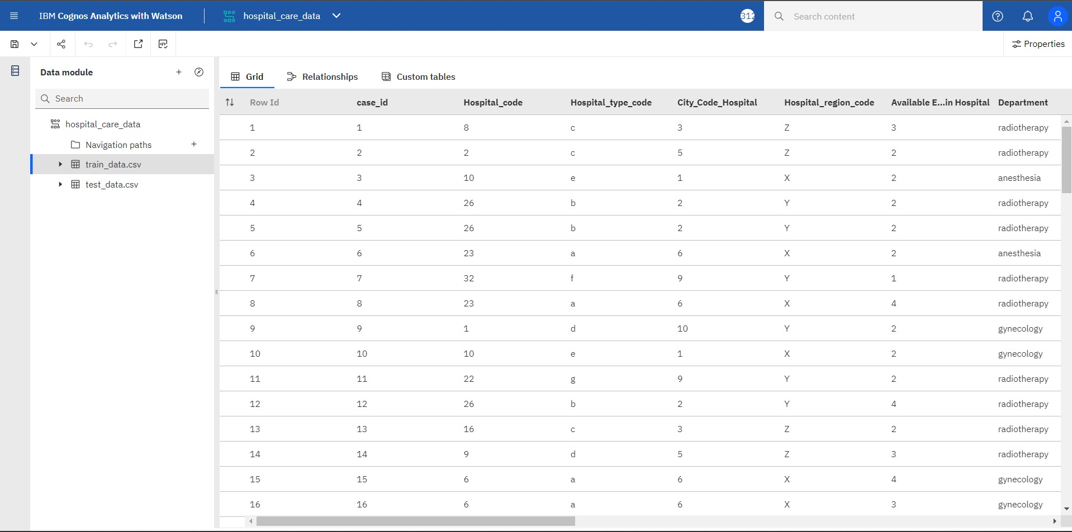

**Null Values Cleaning Process :**

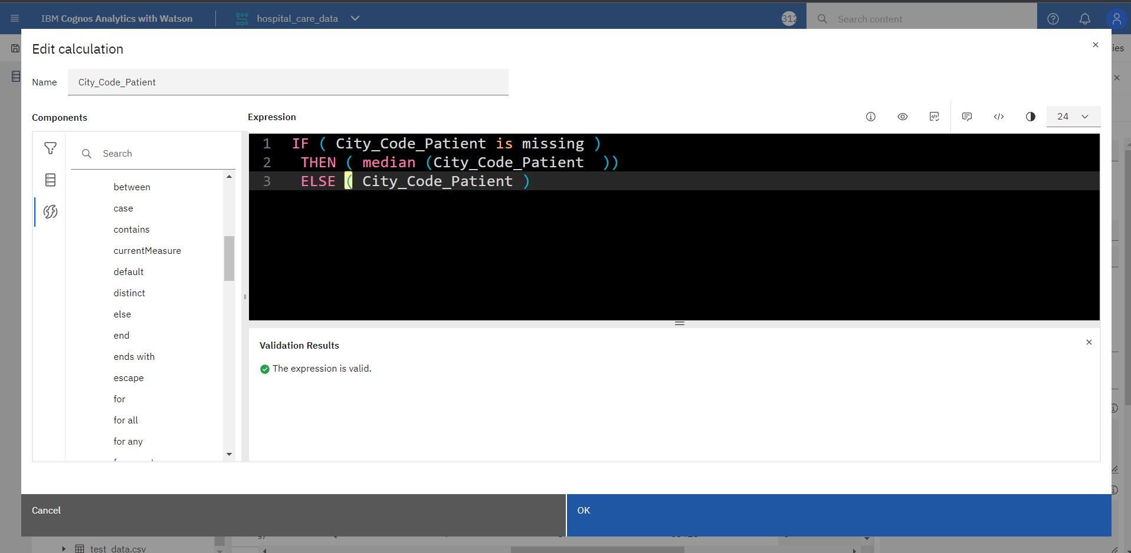

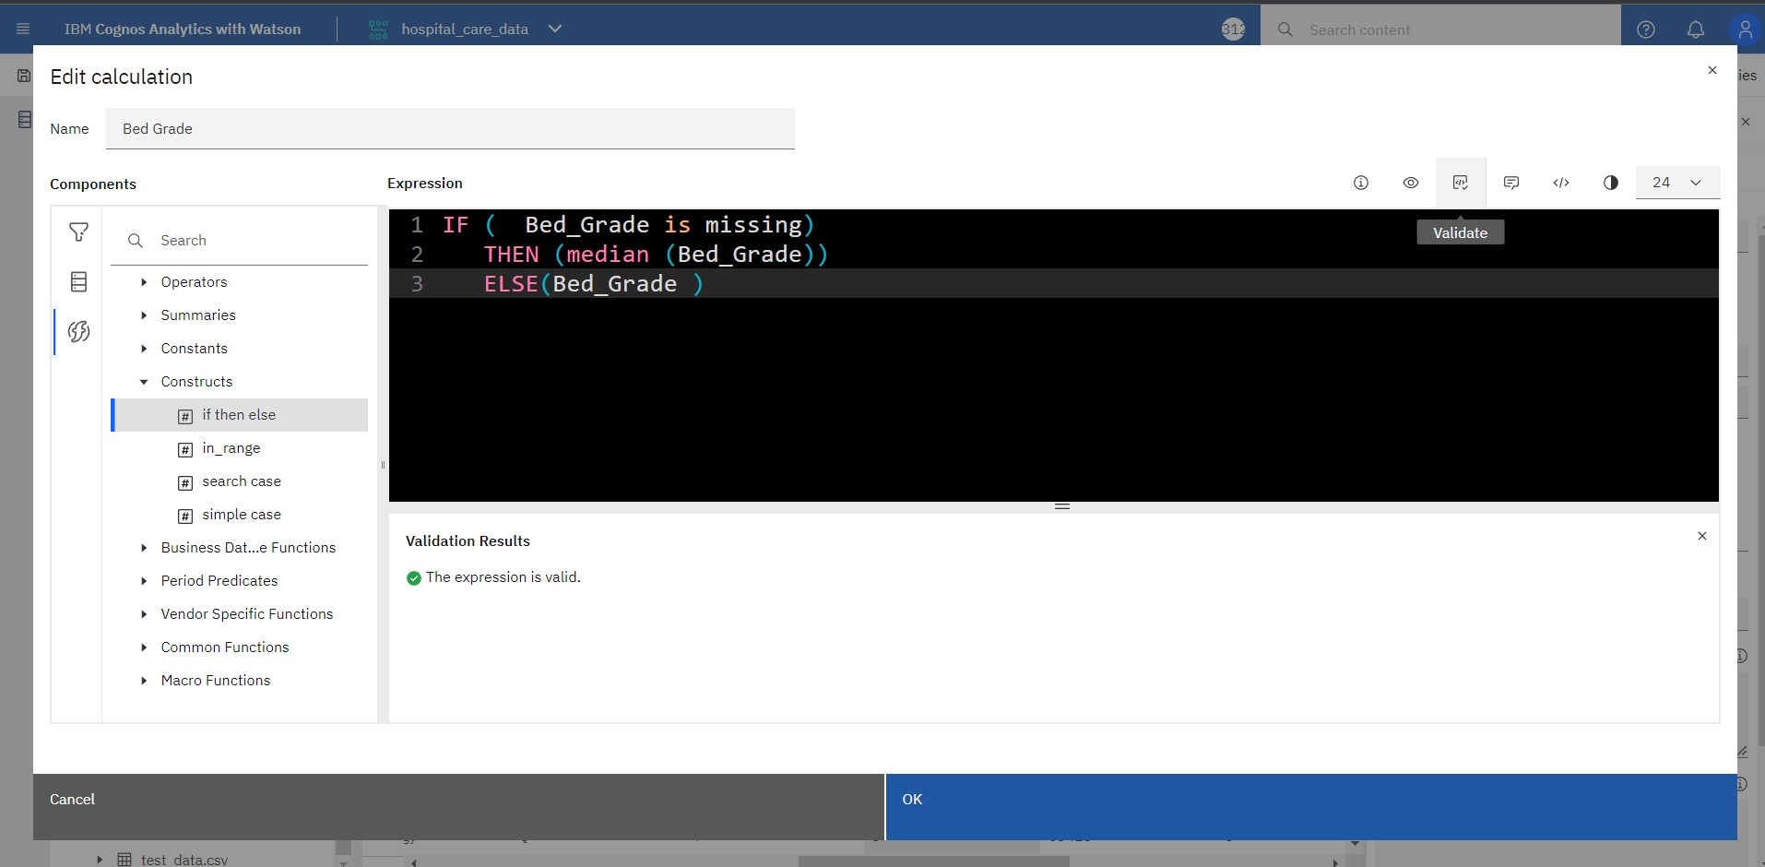

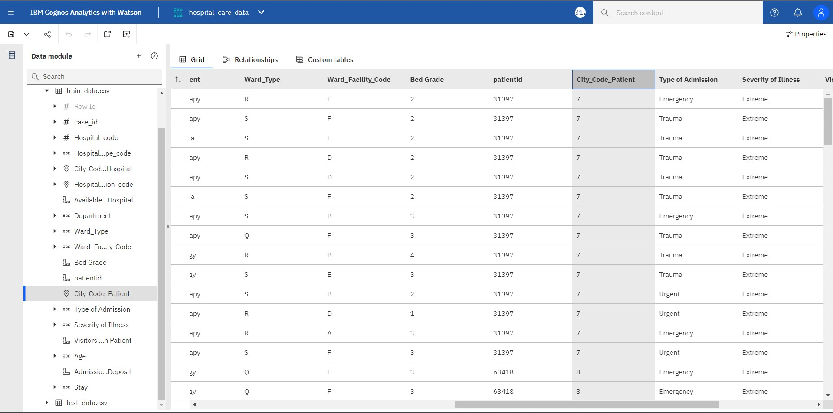

**Hospital Data :**

